Interview Questions



1. Closures
2. Hoisting
3. Promises - https://www.youtube.com/watch?v=ap-6PPAuK1Y&t=11s
4. Map, reduce and filter
5. New feature in ES6
6. Asynchronous
7. Callback functions
8. Solid principles - https://www.youtube.com/watch?v=XI7zep97c-Y

<https://www.simplilearn.com/tutorials/javascript-tutorial/javascript-closure>

Promises –

The Promise object represents the eventual completion (or failure) of an asynchronous operation and its resulting value.

By using promises we solve inversion of control which was there in case of callback function where we give control to some other piece of code to execute our code after there execution.

We also solve callback hell( multiple calls nested inside each other)

A Promise is in one of these states:

pending: initial state, neither fulfilled nor rejected.

fulfilled: meaning that the operation was completed successfully.

rejected: meaning that the operation failed.

Example :-

const promiseA = new Promise((resolve, reject) => {

resolve(777);

});

// At this point, "promiseA" is already settled.

promiseA.then((val) => console.log("asynchronous logging has val:", val));

console.log("immediate logging");

// produces output in this order:

// immediate logging

// asynchronous logging has val: 777

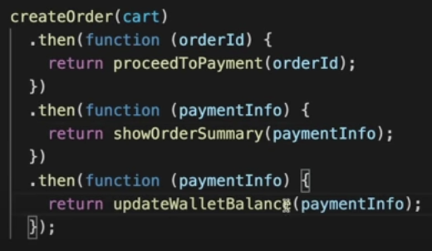

Asynchronous -

Js is synchronous by default.

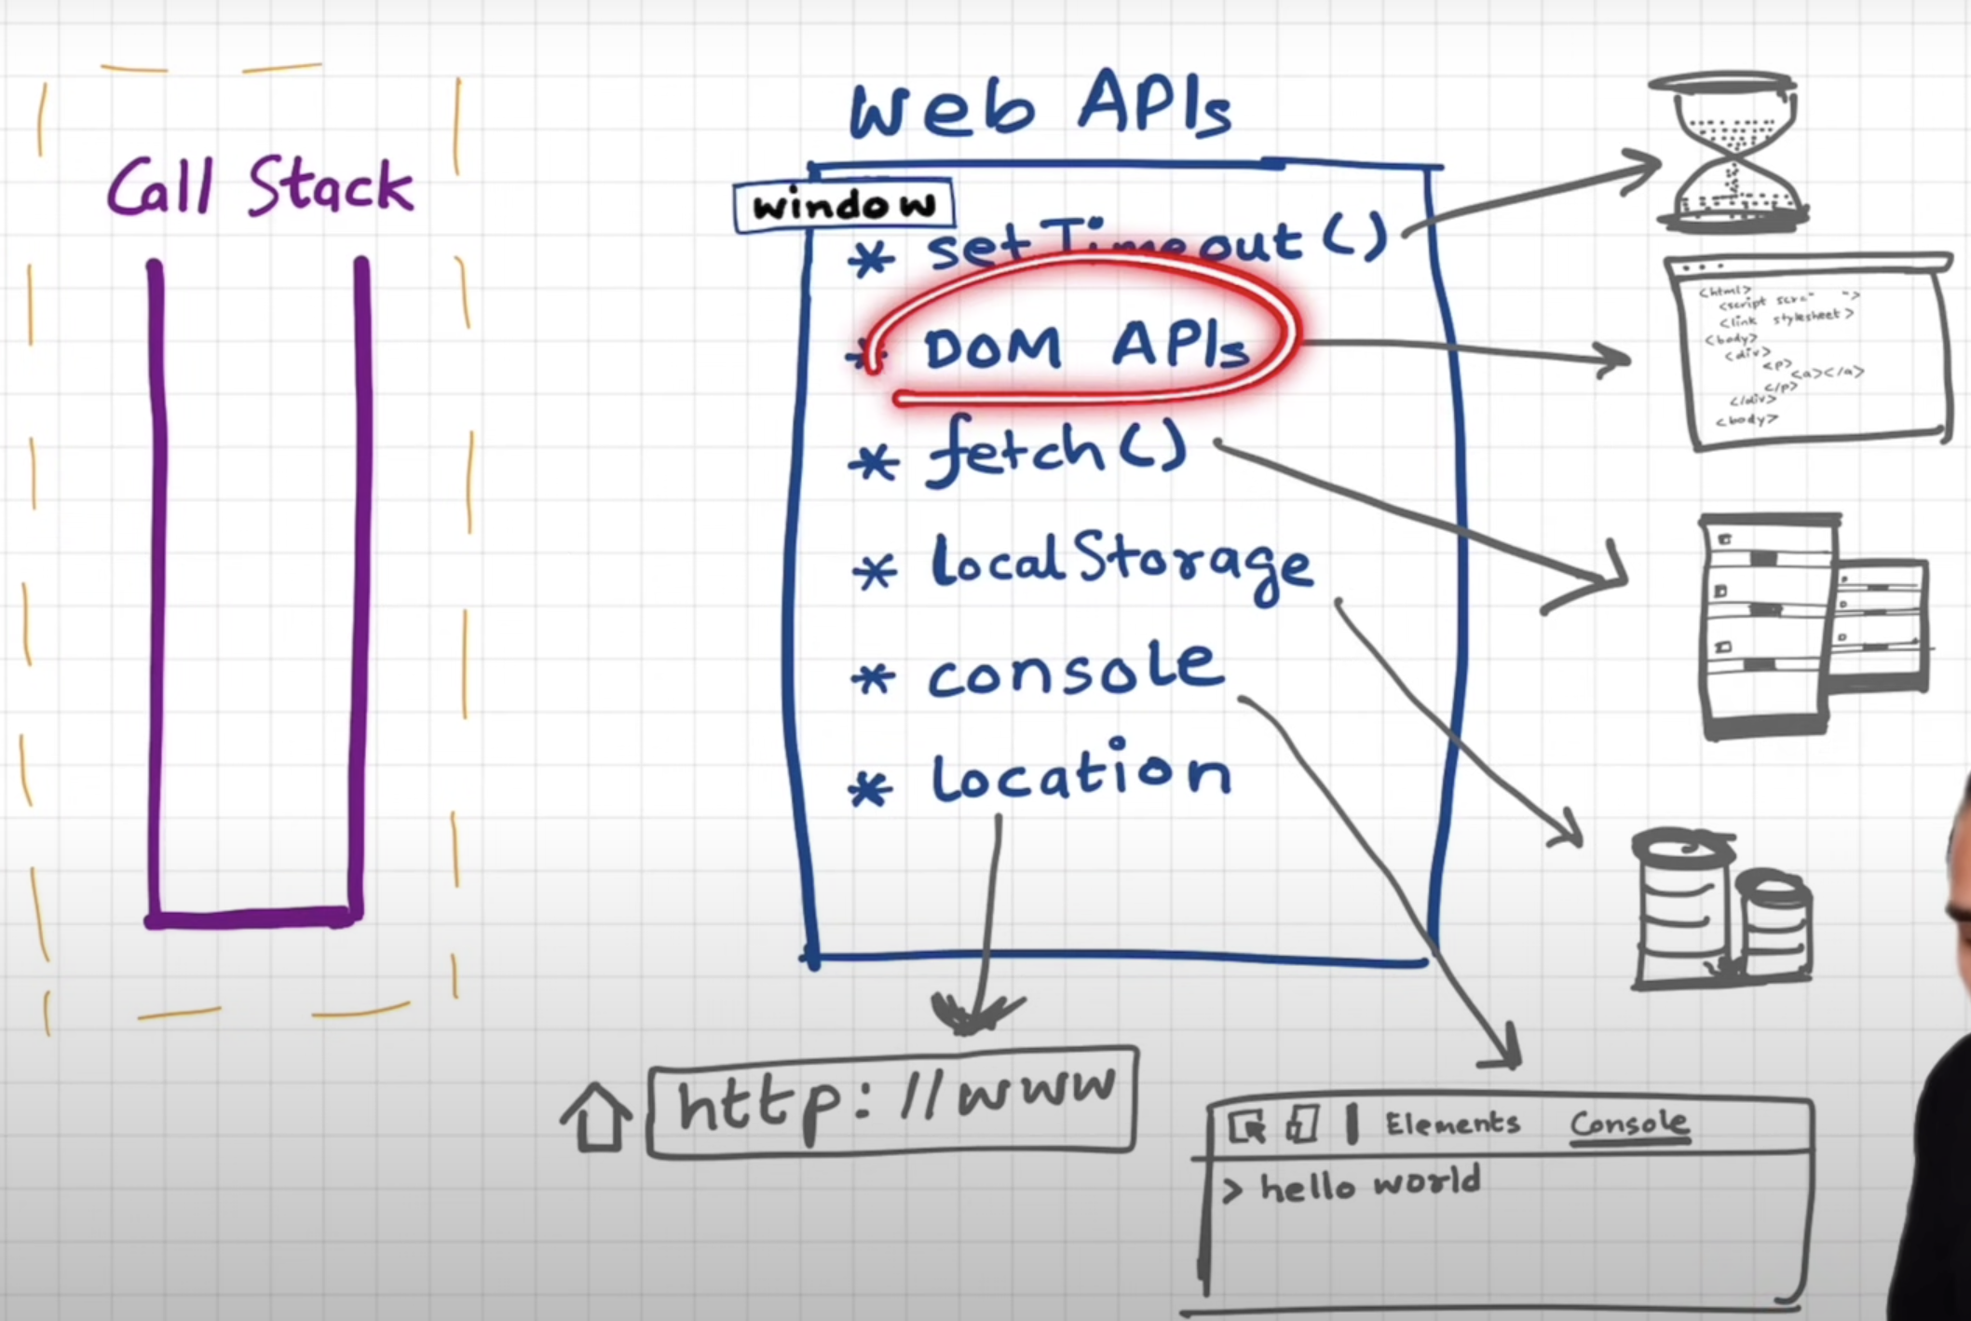

**Async/await is newer and better than using .then().**